Points of Concurrency of a Triangle
Lines | Point of Congruence | Interesting Facts | Figure
Bisectors of the three angles | incenter | The circle inscribed in the triangle has its center at the incenter. | 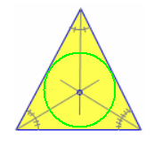
The point where lines connecting each median to its opposite vertex intersect. | centroid | 1. The centroid is the center of gravity of the triangle.  2. The distance from a vertex to the centroid is 2/3 of the distance from that vertex to the midpoint of the opposite side. | 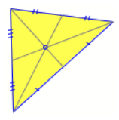
The point where the three perpendicular bisectors of the sides meet. | circumcenter | The circle intersecting all three vertices has its center at the circumcenter (circumscribed circle) | 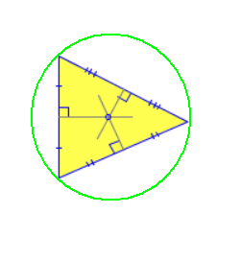
The point of intersection of the three altitudes | orthocenter | If the triangle is acute, the orthocenter is inside the triangle; if the triangle is obtuse, then the orthocenter is outside of the triangle. | 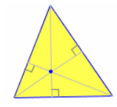
Line of Euler | (alignment, not congruence) | The orthocenter, the centroid and the circumcenter of a non-equilateral triangle are aligned; that is to say, they belong to the same straight line, called line of Euler. | 