Graphing Quadratic Equations (Parabolas)

The “parent graph” of a quadratic equation, is the graph of the most simple quadratic equation: y = x².

If a quadratic equation is written in vertex form, y = a(x-h)² + k, rather than standard form (y = ax² +bx+c), then it is easy to graph and also easy to see what transformations from the parent graph are needed to draw the graph which has its equation in vertex form.

Each of the constants, a, h, and k, play a role, as shown below.

y = a (x-h)² + k

vertical translation of k units
horizontal translation of h units
stretch or compression
if |a| > 1 then compression
if 0 < |a| < 1 then stretch
if a is > 0, the parabola opens upward;
if a is < 0, the parabola opens downward
(reflection about the x-axis).

The pair of graphs on the next page show the parent graph an another graph, who's equation is in vertex form. The various transformations from the parent graph are listed.

Below we see two graphs and their equations. The red graph is the parent graph for quadratic equations, and the blue graph is the graph of a particular equation, written in vertex form.

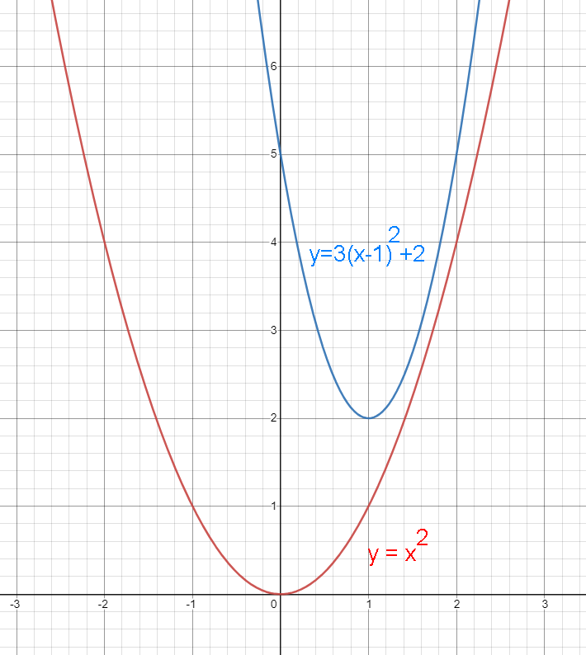
The vertex of the parent graph is at (0,0). The equation in vertex form indicates the location of the vertex, which is at (h,k). In our example equation (the blue equation, above), h = 1 (not -1) and k = 2, so the graph's vertex is at (h,k), or (1,2). Inspection of the blue graph shows that the vertex is at (1,2). From this we conclude that, starting from the parent graph, the blue graph has had the following transformations:
- Horizontal translation of 1
- Vertical translation of 2
The stretch or compression variable, a, is here equal to 3. Thus, the blue graph rises 3 times faster than the parent graph, making the graph stretched vertically – or, equally, compressed horizontally, in either case by a factor of 3. (Can you see this??)

